Create a table Customer

|  |  |  |  |  |  |  |
| --- | --- | --- | --- | --- | --- | --- |
| (CustomerID | , CustomerName, | ContactName, | Address, | City, | PostalCode, | Country) |

|  |  |  |  |  |
| --- | --- | --- | --- | --- |
| Orders (OrderID, | CustomerID, | EmployeeID, | OrderDate, | ShipperID) |

|  |  |  |  |  |
| --- | --- | --- | --- | --- |
| Employees (EmployeeID | LastName | FirstName | BirthDate | Photo) |

CREATE TABLE Customer(CustomerID int, CustomerName varchar(50),ContactName varchar(50),Address varchar(50),City varchar(50),PostalCode int,Country varchar(50));

CREATE TABLE Orders (OrderID int,CustomerID int,EmployeeID int,OrderDate date,ShipperID int);

CREATE TABLE Employees (EmployeeID int,LastName varchar(50), FirstName varchar(50),BirthDate date);

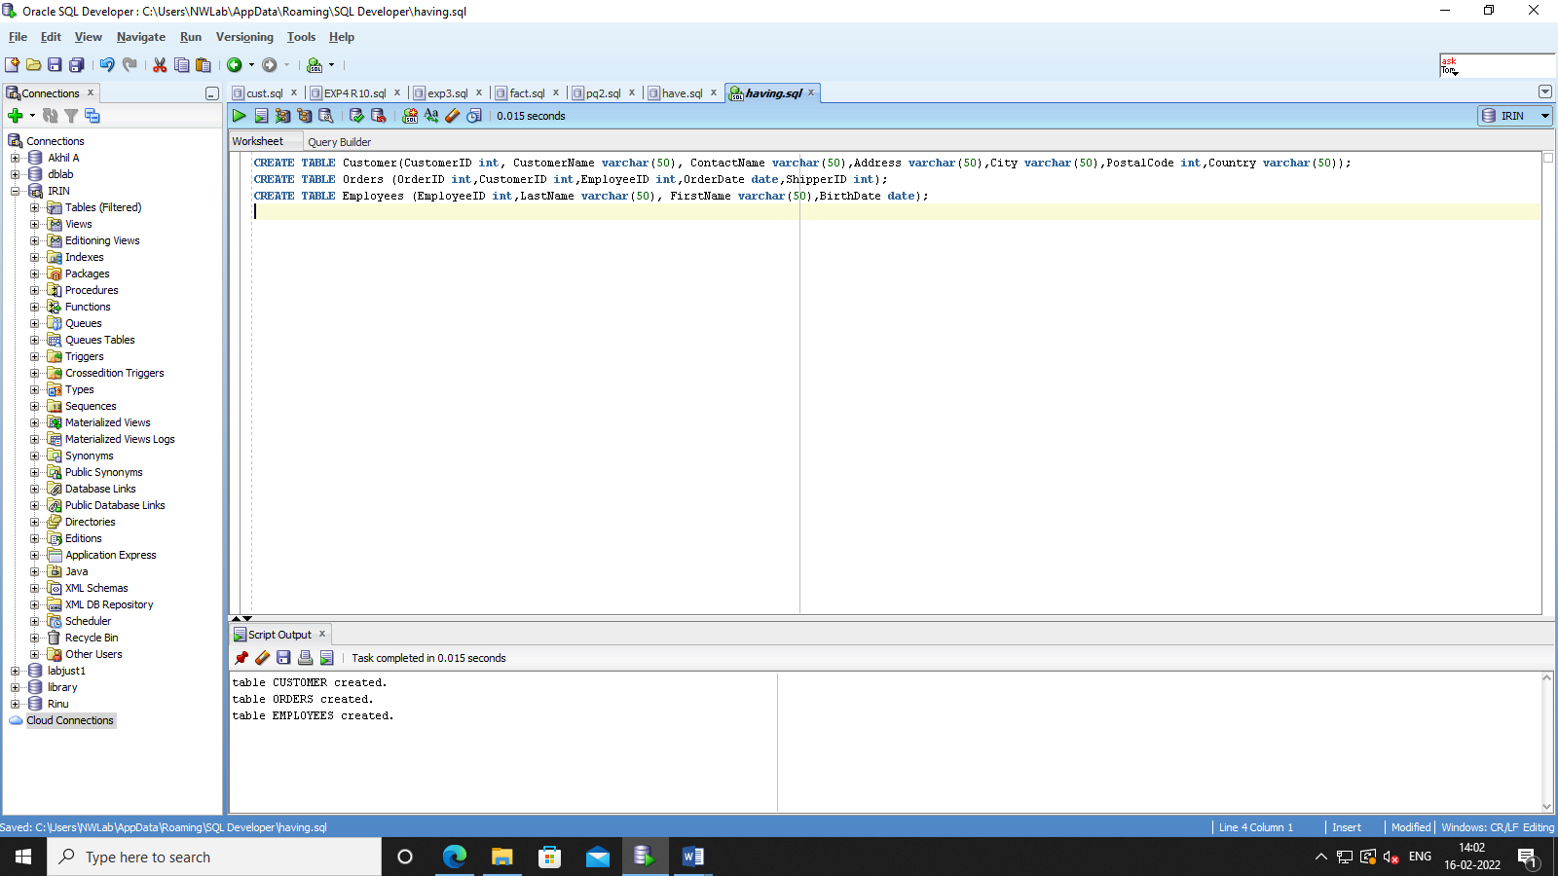

INSERT INTO Customer Values(101,'Jeon','Jeon Junkook','Busan','Seoul',2303,'South Korea');

INSERT INTO Customer Values(102,'Hoba','Jung Hoseok','Deagu','Namsan',2612,'South Korea');

insert into Customer values(103,'Rkive','Kim Namjoon','Vincent Street','Down Valley',1405,'New York');

insert into customer values(104,'Suga','Min Yoongi','Vampire Street','Mystic Falls',2810,'South Korea');

insert into Customer values(105,'thv','Kim Tae','Gonju','Cin Street',2812,'South Korea');

insert into customer values(106,'Klaus','Klaus Mikaelson','orginals','neew orealnds',95034,'America');

insert into Customer values(107,'Jin','Kim Seokjin','Han street','Seoul',5854,'South Korea');

insert into Customer values(108,'Moch','Park Jimin','Busan','Seoul',7707,'South Korea');

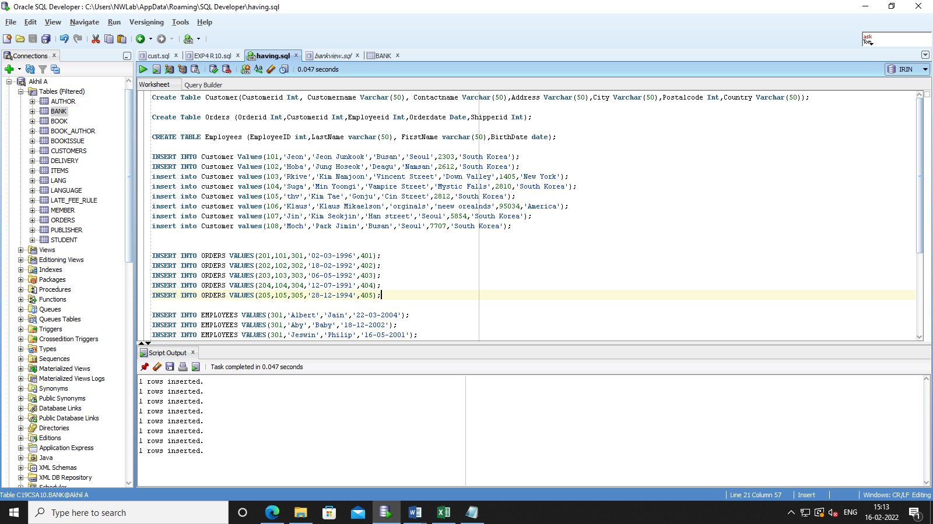

INSERT INTO ORDERS VALUES(201,101,301,'02-03-1996',401);

INSERT INTO ORDERS VALUES(202,102,302,'18-02-1992',402);

INSERT INTO ORDERS VALUES(203,103,303,'06-05-1992',403);

INSERT INTO ORDERS VALUES(204,104,304,'12-07-1991',404);

INSERT INTO ORDERS VALUES(205,105,305,'28-12-1994',405);

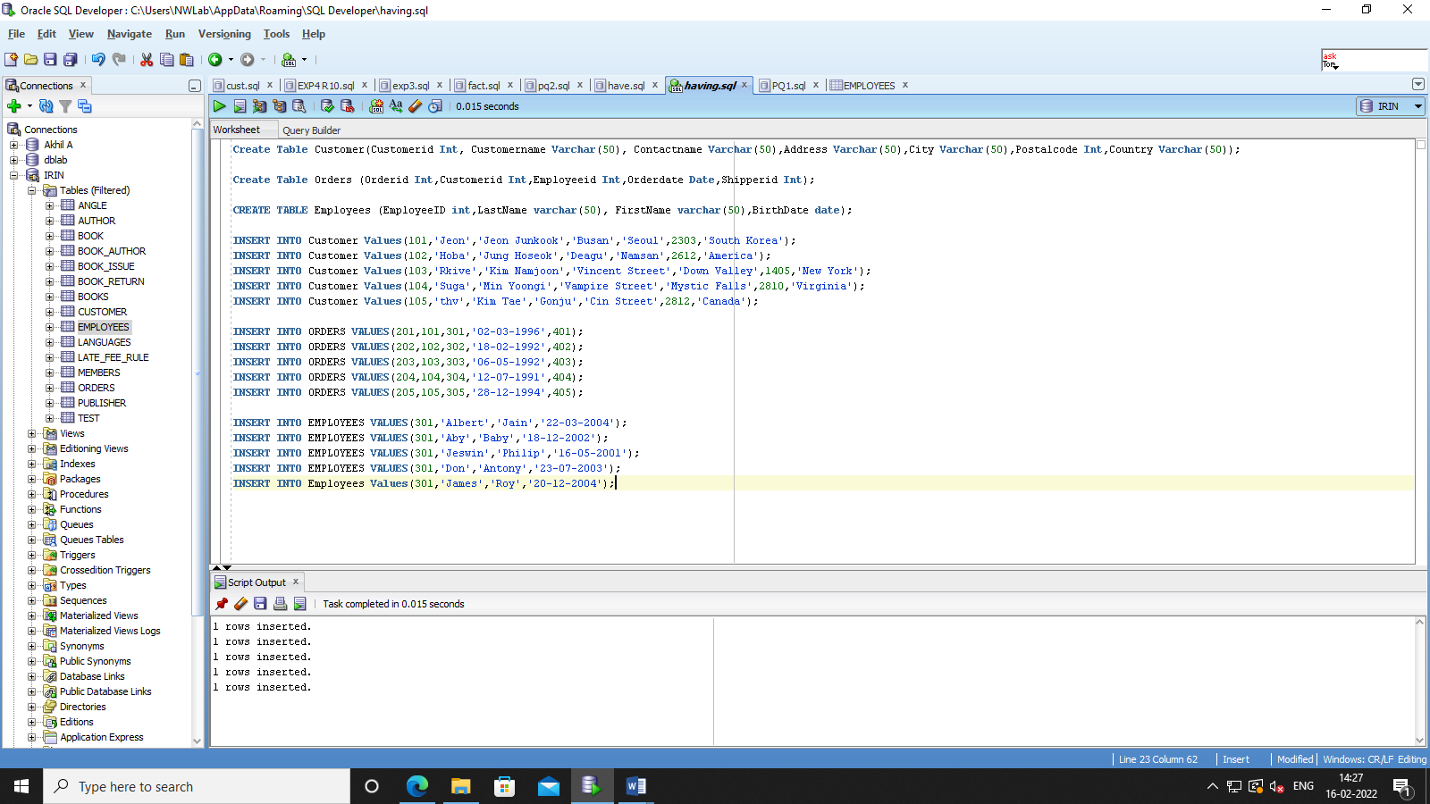

INSERT INTO EMPLOYEES VALUES(301,'Albert','Jain','22-03-2004');

INSERT INTO EMPLOYEES VALUES(302,'Aby','Baby','18-12-2002');

INSERT INTO EMPLOYEES VALUES(303,'Jeswin','Philip','16-05-2001');

INSERT INTO EMPLOYEES VALUES(304,'Don','Antony','23-07-2003');

INSERT INTO Employees Values(305,'James','Roy','20-12-2004');



1. Lists the number of customers in each country. Only include countries with more than 5 customers: (HINT:  GROUP BY, HAVING)

select count(Customerid),Country from Customer group by Country having count(Customerid) > 5;

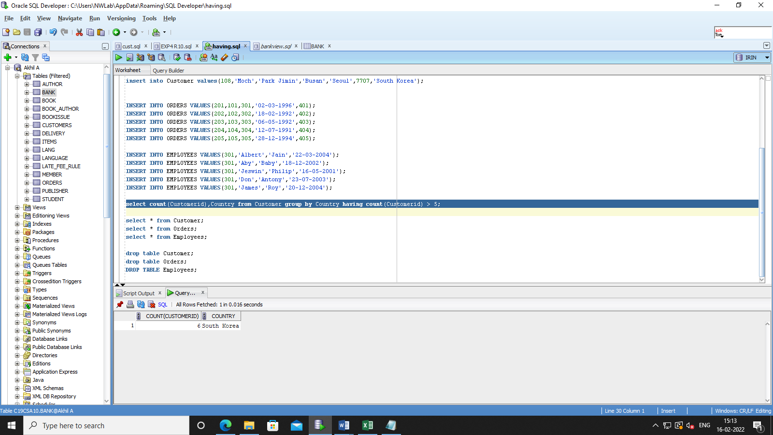

1. Lists the number of customers in each country, sorted high to low (Only include countries with more than 5 customers)

select count(customerid),country from customer GROUP BY Country having count(customerid) > 5

ORDER BY COUNT(CustomerID) DESC;



1. Lists the employees that have registered more than 10 orders: